CEWA 565 Project Paper:

Snow melting and stream temperature trend analysis within Yosemite National park area

Ximin Hu & Lightman He

1. Introduction

Recent years, people have talked about stream temperatures being unhealthy for fish if snow melts earlier, which results in early stream flow. In current study we used the hydroclimate data from Yosemite national park area to do the analysis on the relationship between air temperature, snow melting and subsequent effects of the streams as a pioneer study for revealing how will the climate change affect the aquatic life.

As searching out the literatures, there were lots of researches also validated that the water temperature has a negligible adverse health effect to fish. Some of the fish were proved to have thermal limit thus higher temperature is not suitable to them1. There were also evidence that warmer climate will lead to the decrease of aquatic life diversity and population2. Thus as the first step, we need to figure out the relationship between air temperature and stream flow, and then use the relationship or change overtime to explain what is going on within the natural system.

For this project, data were provided from previous monitoring log, we picked two site: lyell and tuolumne as our study site, while the major part of analysis were done on the lyell site. Fig.1 shows the sampling station.

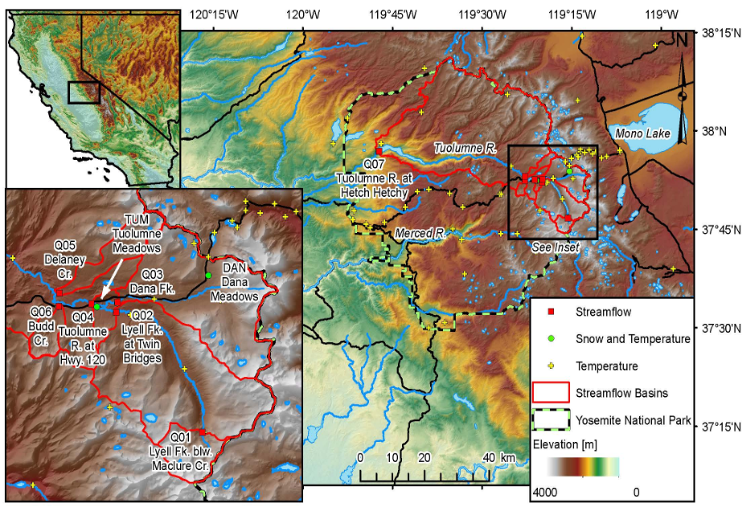

*Fig 1. Yosemite national park hydroclimate data collecting station. Site Q01. Lyell and Site Q04. Tuolumne were selected in this study.*

Detailed geographic information is also provided within the dataset:

Air Temperature measurement site: Dana Fork, latitude 37°52'33", longitude 119°20'04" NAD83, gage datum 8,654 feet above NAVD88;

Q01 site: LYELL FORK TUOLUMNE R BL MACLURE C NR, latitude 37°46'40", longitude 119°15'41" NAD83, gage datum 10,200 feet above NGVD29;

Q04 site: TUOLUMNE R AB HWY120, latitude 37°52'34", longitude 119°21'14" NAD83, gage datum 8,580 feet above NGVD29.

Generally, we proposed the physical process of water temperature rise as following: The cycle begins from the air temperature increase which take place during the late spring each year, the snow melted after temperature get warmer, initialized the stream flow, then the water temperature rises along with the air temperature, and eventually affect any aquatic life living in neighborhood area. Other environmental factors could also play role in this process, such as precipitation, radiation, location of the site and etc, which will also be discussed in the later sections.

1. Questions and statistical analysis

As mentioned in previous section, our core question is to figure out the relationship between air temperature, snow melting and stream flow. To make this question simpler and better understanding the whole process, we break done the core question into four parts: a) did stream behavior varies during different periods; b) figure out the relationship between air temperature and discharge increase; c) figure out the relationship between air temperature and water temperature; d) did sites’ size and location affect the relationship.

Before the analysis, all the dataset were cleaned to delete out the NA columns and abnormal data point. In current study we only used data from 2009-2015. As to reduce the autocorrelation effect, all the data were resampled down to the week period scale. Fig 2. showed the comparison between original data and resampled data from site Q01.

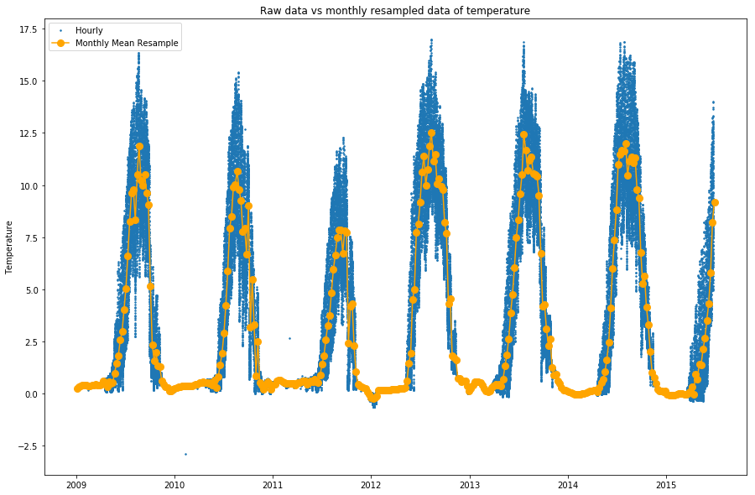

*Fig 2. Raw data vs weekly resampled data from site Q01, lyell river.*

The overview of the stream data and temperature data were visualized to help us set our hypothesis, Fig 3. showed an example also from site Q01 of the visualization of all variables throughout whole time period selected.

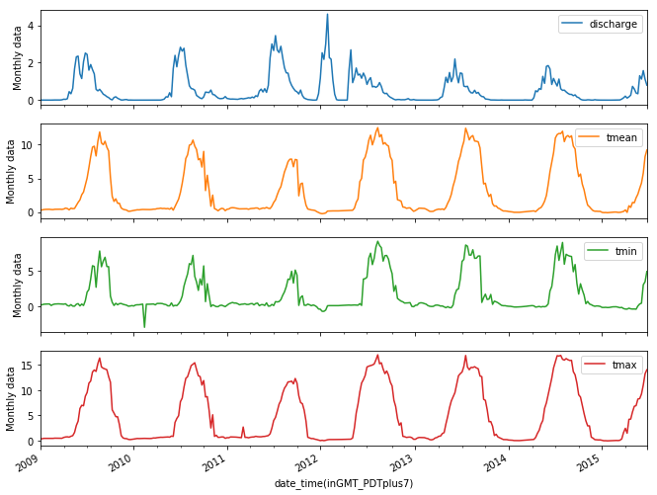

*Fig 3. Time trend for water temperature and discharge of site Q01 throughout 2009-2015. A subtle change is witnessed around 2012.*

Based on the data and the visualization plot, we saw a similar pattern for two site and also the air temperature data. There was a change happened around 2012 on the plots, thus we set the 2012 as a slicing point for our data set to initialize subsequent analysis.

1. Results
   1. Hypothesis test

We proposed a hypothesis that the air temperature, water temperature and discharge changed around 2012. The hypothesis testing is used to validate our guess.

First, we need to create a null and an alternative hypothesis. In our study, the null hypothesis (H0) is that there is no change happens around 2012, the alternative hypothesis is that there is a change happens around 2012, while detailed comparison criteria were decided directly from the data, i.e, if a larger average trend is confirmed in later period then we use μl>μp and vice versa, and to set α at 5%. Here we presented Site Q01 data as an example.

H0 :

H1 :

The results were shown in fig 4. As suggested by the testing, by 95% confidence we can tell there is a significant change happened around 2012.

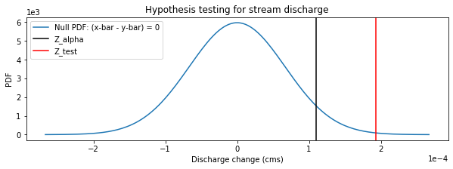

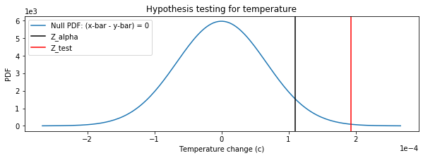

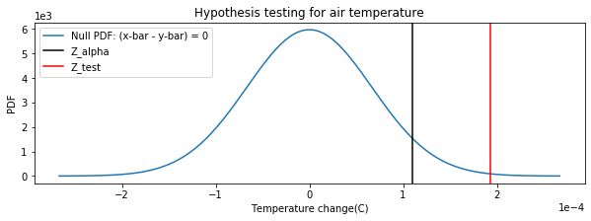

*Fig 4. Hypothesis testing results for air discharge, average water temperature and average air temperature changes around 2012. The result shows that air and water temperature significantly increased after 2012 while the discharge significantly decreased after 2012.*

The result suggested that there was a significant change happened around 2012. Which validate our thought that the factors we selected were connecting to each other.

* 1. Relationship between air temperature and discharge

After confirmed the relationship between air temperature and stream behavior, the detailed validation on each variables was done. Here we used a ‘rising point’ approach to find out the relationship between air temperature and stream discharge initialization. By creating a cumulative curve for discharge of each year, we assume that the time point of 20% total discharge is that stream rising point. Matching the rising point with the air temperature will give us a insight of when the warmer temperature leads to the stream discharge increase. As in part a, all plots from this section were from site Q01.

Fig 5. showed an example of deciding the rising point for 2009.

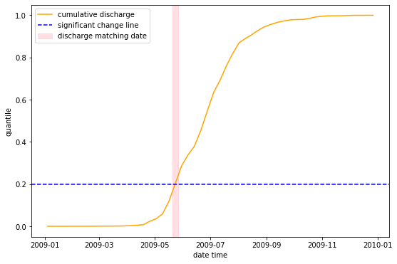

*Fig 5. Rising point plot for 2009. The intersection between cumulative discharge and 20% vertical line indicates the rising point for the stream. The data were roughly decided since the error is acceptable.*

All the rising points were stacked together along with the air temperature time trend plot after being selected out, to visualize the relationship between this rising point and air temperature. The result is showed in Fig 6.

*Fig 6. Discharge increase date vs temperature plot. The red dashed line indicates the rising point for each year, blue solid line showed average air temperature which resampled down to week scale.*

As above, all results from this section suggests that the discharge was initialized by the air temperature increase.

* 1. Relationship between air temperature and water temperature
  2. Comparison of two sites at different locations

1. Discussion
   1. How well did we answer the question?
   2. Is there any other thing needed to improve the analysis?
   3. Illustrate in the real case how will the air temperature affect the fish (if there is any relationship)

1 Effects of high temperatures on threatened estuarine fishes during periods of extreme drought. Ken M. Jeffries et al, Journal of Experimental Biology 2016 219: 1705-1716; doi: 10.1242/jeb.134528

2 Climate warming reduces fish production and benthic habitat in Lake Tanganyika, one of the most biodiverse freshwater ecosystems. Andrew S. Cohen et al, PNAS August 23, 2016 113 (34) 9563-9568; doi: https://doi.org/10.1073/pnas.1603237113